Consumer Behavior Analytics Report

Executive Summary
This project presents an end-to-end Consumer Behavior Analytics solution developed to analyze retail transaction data and convert it into actionable business intelligence. The objective of the analysis was to understand revenue drivers, consumer purchasing behavior, product performance, and operational preferences to support strategic decision-making.
The analysis is based on 3,900 transaction-level records, generating a total revenue of $233,080 with an average purchase value of $59.76 and an average customer rating of 3.75. Promotional offers were applied in 43% of total transactions, indicating strong consumer responsiveness to discounts.
A fully interactive Power BI application was designed and deployed, featuring both desktop and mobile-optimized dashboards. The solution enables stakeholders to explore performance metrics, segment consumers, evaluate promotion and subscription effectiveness, and identify high-value transaction patterns.

1. Business Problem Statement
Retail organizations generate large volumes of transactional data daily; however, without structured analytics, it becomes difficult to translate this data into meaningful insights. Key business challenges include:
- Identifying primary revenue-driving customer segments
- Understanding product and category performance
- Measuring the impact of promotions and subscriptions
- Recognizing high-value and abnormal transaction behavior
- Enabling leadership with real-time, self-service analytics
This project addresses these challenges by building a centralized analytics dashboard that transforms raw transactional data into decision-ready insights.

2. Business Objectives
The primary objectives of this project were:
- Analyze overall revenue performance and spending distribution
- Understand customer demographics and purchasing behavior
- Identify top-performing products and categories
- Evaluate promotion and subscription effectiveness
- Assess operational preferences such as payment and shipping methods
- Deliver a professional, enterprise-grade BI application

3. Dataset Overview

Data Source
Retail consumer transaction dataset

Dataset Characteristics
- Total Transactions: 3,900
- Total Customers: 3,900
- Granularity: Transaction-level (one record per purchase)
- Final Attributes: 23 analytical fields

Key Data Elements
- Customer demographics (age, gender, age group)
- Product details (item, category, size, color)
- Transaction values (purchase amount, units sold)
- Operational attributes (payment method, shipping type)
- Behavioral indicators (previous purchases, promotions, subscriptions)

4. End-to-End Project Architecture
The project followed a complete analytics lifecycle:
Raw Data (CSV) → Data Cleaning & Validation (Python) → Feature Engineering → SQL-Based Business Analysis → Power BI Semantic Model → Power BI Service Deployment → Power BI App (Desktop & Mobile)
This ensured full traceability, scalability, and analytical integrity.

5. Data Preparation & Feature Engineering

Data Cleaning Activities
- Validation of numerical ranges for age, ratings, and purchase amount
- Standardization of categorical values
- Handling of missing and inconsistent entries
- Removal of redundant fields

Feature Engineering
Business-driven features were created to enhance analytical depth:
- Age Group Classification (Teen, Young Adult, Adult, Senior)
- Promotion Exposure Flag
- High-Value Transaction Flag
- Express Shipping Indicator
- Purchase Frequency Approximation
- Outlier Transaction Identification
These features enabled behavioral and value-based analysis beyond basic reporting.

6. Dashboard Design Overview

Dashboard Name
Consumer Insights & Revenue Performance Dashboard

Design Principles
- Executive-first KPI layout
- Consistent navigation across pages
- Dark enterprise theme
- Interactive slicers for dynamic filtering
- Page-level storytelling
- Optimized mobile experience
The dashboard was designed to support both strategic review and detailed exploration.

7. Dashboard Pages & Analytical Insights

7.1 Executive Summary Page
Purpose: Provide a consolidated overview of business performance.
Key components include: - Total Revenue - Total Customers - Units Sold - Average Rating - Promotion Usage
Insights: - Revenue distribution shows balanced contribution across categories - Customer base demonstrates stable engagement levels - Promotions are actively utilized without reducing order value

(Dashboard Screenshot – Summary Page)
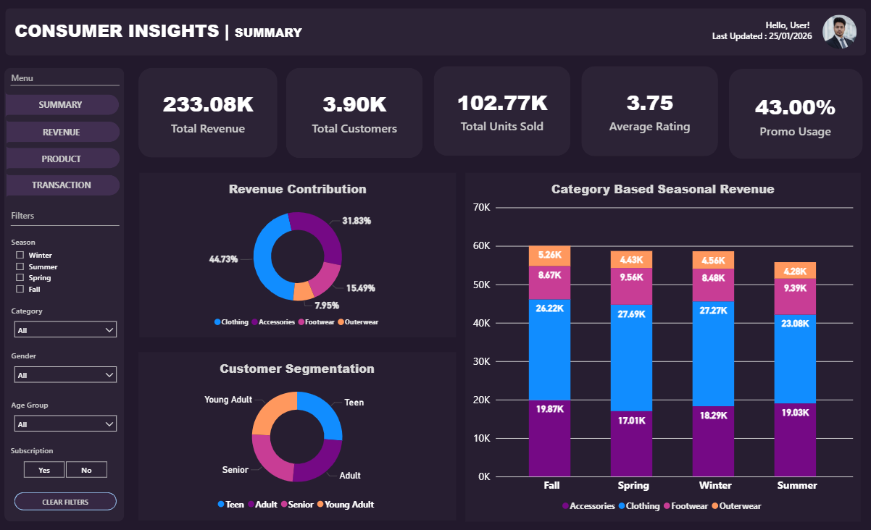

7.2 Revenue Analysis Page
Focus Areas: - Revenue by Category - Revenue by Season - Revenue by Gender - Revenue by Age Group - Subscription Impact
Key Findings: - Clothing category contributes the highest share of total revenue - Adult and Young Adult segments generate the majority of sales - Male customers contribute a larger revenue share - Subscribed customers demonstrate higher spending behavior

(Dashboard Screenshot – Revenue Analysis)
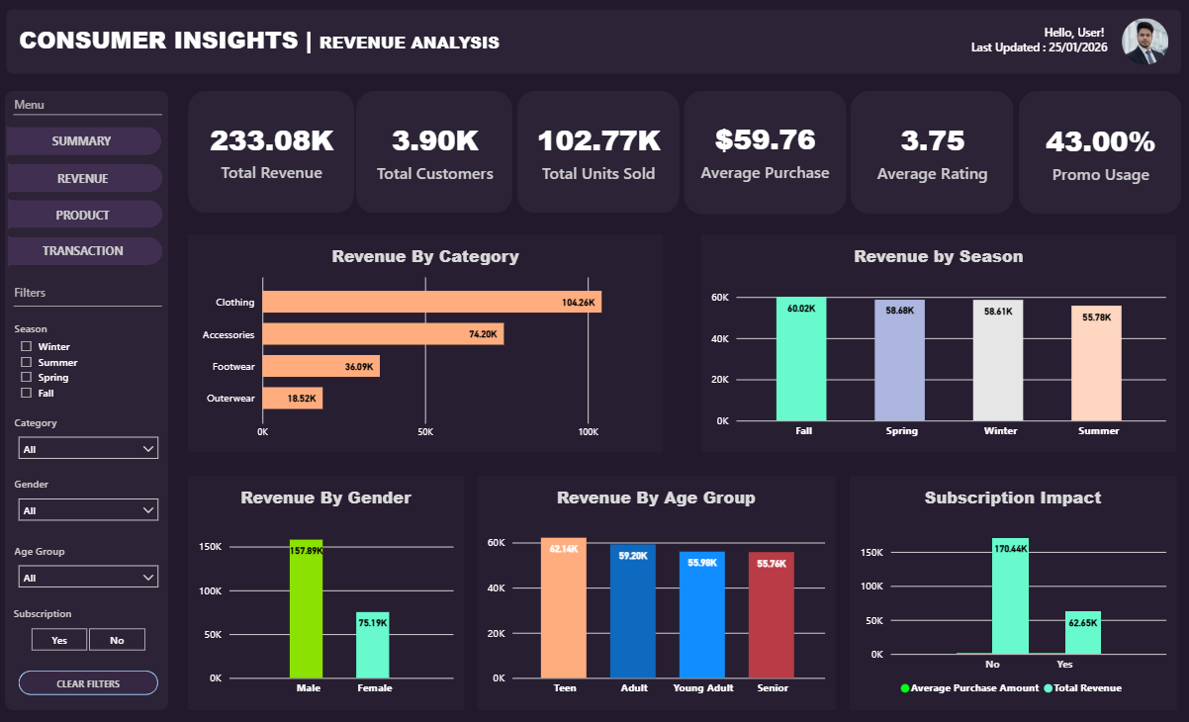

7.3 Product Performance Page
Focus Areas: - Top Products by Revenue - Product Ratings Analysis - Payment Method Preferences - Shipping Type vs Spend
Key Findings: - A small group of products contributes disproportionately to revenue - Average product ratings remain stable between 3.7–3.8 - Digital payment methods dominate transaction volume - Faster shipping options correlate with slightly higher spend

(Dashboard Screenshot – Product Performance)
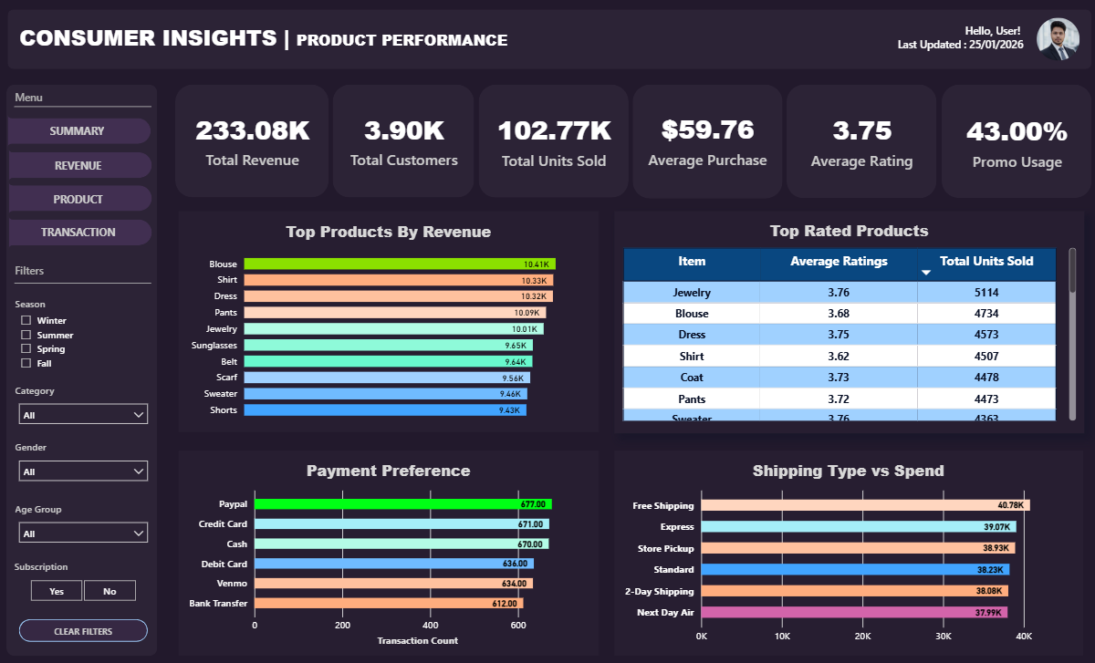

7.4 Transactions Data Page
Purpose: Enable granular transaction-level analysis and validation.
Features: - Detailed transaction table - Multi-dimensional filtering - Drill-through support
This page supports operational review and data transparency.

(Dashboard Screenshot – Transactions Table)
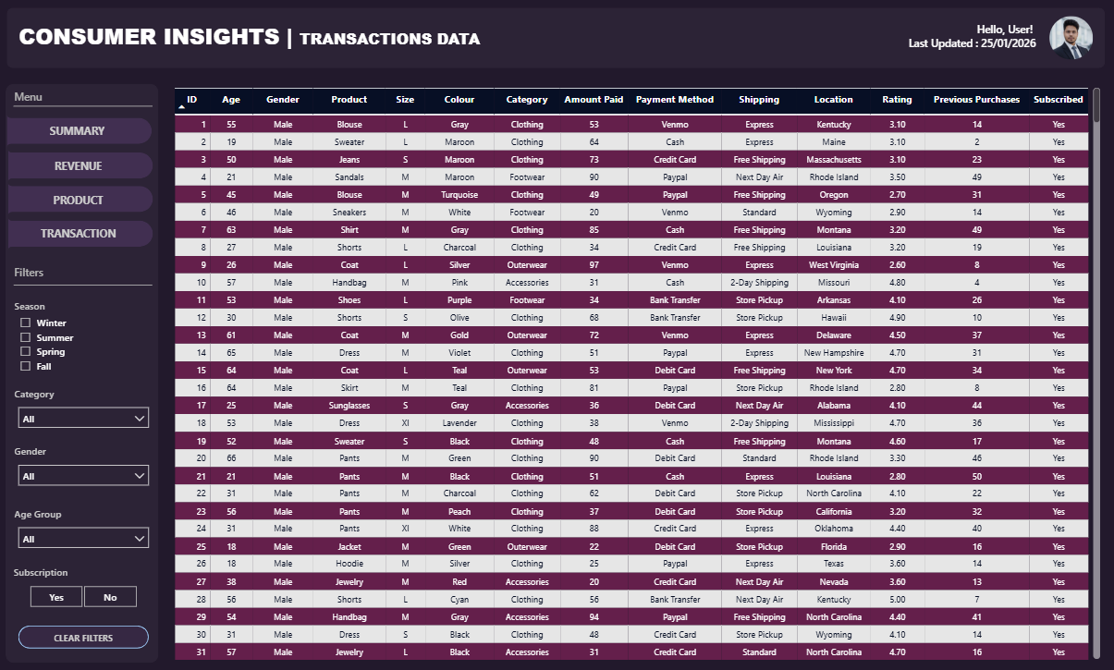

8. Mobile Dashboard Experience
A dedicated mobile layout was developed to support executive and on-the-go consumption.
Mobile Design Highlights: - KPI-first vertical layout - Simplified visuals - Optimized slicers - Consistent branding
The mobile dashboard allows leadership to access insights anytime via the Power BI mobile application.
(Mobile Dashboard Screenshots)
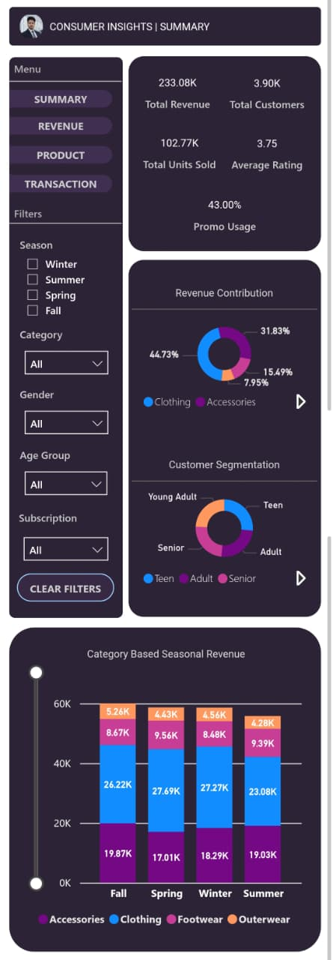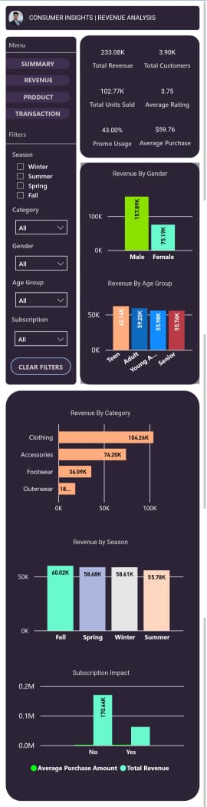
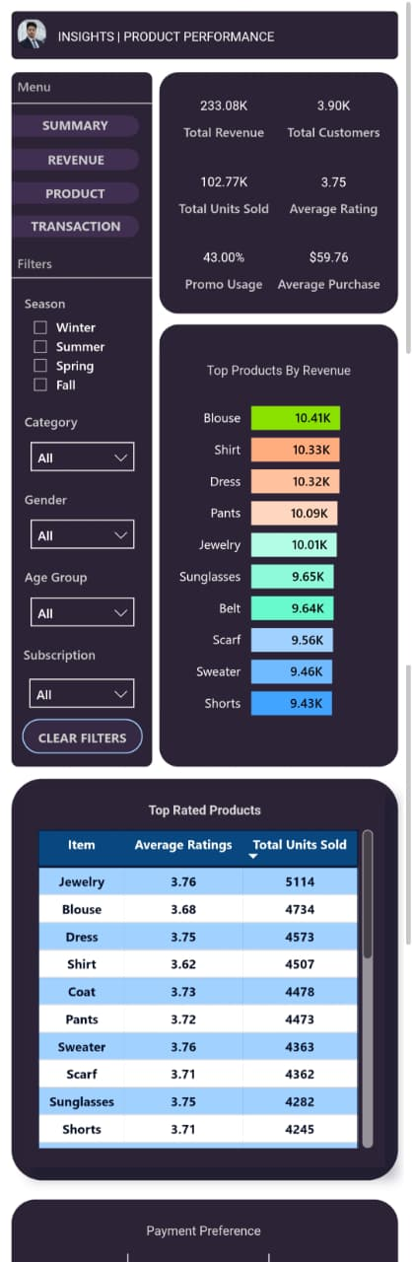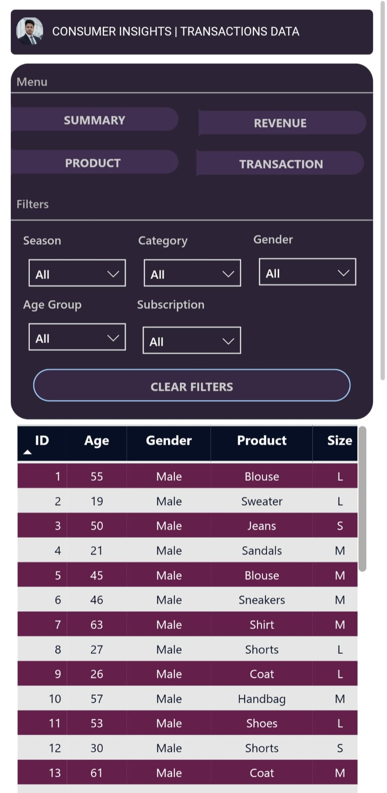

9. Key Business Insights
- Clothing and Accessories are the strongest revenue-generating categories
- Adult and Young Adult customers represent the highest value segments
- Promotions drive engagement without lowering average order value
- Subscription customers exhibit stronger purchasing behavior
- Seasonal revenue remains balanced, with category-level variation
- Express shipping and digital payments align with higher spend patterns

10. Business Recommendations

Marketing Strategy
- Implement targeted promotions instead of blanket discounts
- Focus campaigns on high-spend demographic segments

Product Strategy
- Prioritize inventory planning for top-performing categories
- Use high-rated products for bundling and cross-selling

Customer Engagement
- Convert repeat buyers into subscribers through loyalty incentives
- Personalize offers using behavioral indicators

Operational Optimization
- Promote express shipping as a premium service
- Strengthen partnerships with preferred digital payment platforms

11. Tools & Technologies Used
- Python (Pandas, NumPy)
- SQL (Business Analysis Layer)
- Power BI Desktop
- Power BI Service
- Power BI App
- Gamma AI (Presentation)

12. Limitations & Assumptions
- Dataset does not include transaction timestamps
- Purchase frequency values are approximated
- Review ratings are subjective
These limitations were addressed through feature engineering and analytical assumptions.

13. Conclusion
This project demonstrates the complete analytics lifecycle—from raw data processing to enterprise-level business intelligence delivery.
By integrating data engineering, SQL analytics, and Power BI visualization, the solution provides decision-makers with clear visibility into consumer behavior, revenue drivers, and strategic opportunities.
The Consumer Behavior Analytics Dashboard serves as a scalable foundation for data-driven retail decision-making and reflects industry-standard BI development practices.

